# 05. Simple Web Page

*QA specialists often use HTML and CSS in their work, especially when testing web applications and websites. QA specialists may create test cases and test scenarios using HTML to structure and format the content. HTML allows them to organize the test case information, headings, steps, expected results, and other relevant details in a structured manner. They may be responsible for setting up test environments, including configuring and customizing HTML and CSS templates or themes. This involves modifying HTML and CSS files to ensure the test environment matches the desired specifications.*

## Creating a Simple Web Page:

* Create a Web Page like the one presented in the Screenshot:



## Instructions & Requirements:

* You have been provided with a **.zip file** containing an **index.html** and **style.css** file.
* **Extract** the contents of the **.zip** file to a **folder of your choice**.
* Open the **index.html** file in a **text editor** or an integrated development environment (**IDE**), for example **Visual Studio Code**.
* Make the following changes to the **index.html** file:
  + Change the title of the web page to **"Software Tech Fund"**.
  + Modify the text within the **<h1>** tag to say **"**Exam Page - Third Group**"**.
  + Update the text within the **<p>** tag to say **"**Stay **focused**, stay **determined**, and give it your all!". The words **"focused"** and **"determined"** should be **bolded**, **only these two words**.
* Open the **style.css** file in a text editor or an integrated development environment (IDE).
* Write the necessary **CSS rules** to achieve the following **styling**:
  + Set the **background** color of the **body** element to #**ECF8F9**
  + Set the **font size** of **all elements** to **18 pixels**.
  + Set the **font family** for **all elements** to **"Arial, Helvetica, sans-serif"**.
  + Set the **text color** of **all elements** to **#E55807**

## How to Send Solutions in Judge?

* Make a **zip** archive of your solution by **right-clicking on the index.html file.**

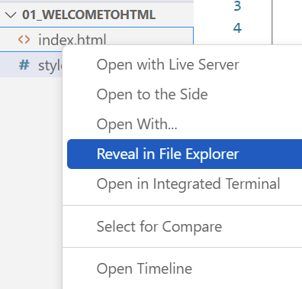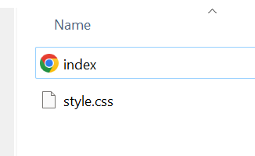

* **"CTRL + A"** to select both files and Compress to ZIP file:

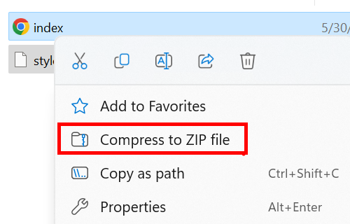

* **Upload** the **compressed file** to Judge and **Submit**:

